Page Template Design Specification for Mosepele Travel & Tours Website

Project: SCIS WMD_2026 A01
Author: Bokamoso Bernadette Selelo
Date: 09/03/2026
Version: 1.0

1. Introduction

This document outlines the page template design for Mosepele Travel & Tours' official website. It acts as an important connection between the final visual interface and the information architecture (site structure, navigation). Every template outlines the design, content blocks, functional components, and user interactions for a certain kind of webpage on the website.
Ensuring uniformity, reusability, and consistent user experience throughout the site is the goal. Standardizing templates improves development efficiency, maintains brand coherence, and makes maintenance easier in the future.
Every template listed here complies with:
- Using Bootstrap 5, responsive design prioritizes mobile devices.
- Accessibility: ARIA labels when appropriate and semantic HTML5.
- Mosepele's tone of voice, typeface, and color scheme all contribute to brand consistency.

2. Common Structural Elements (Global Templates)
The following components are included on every page of the website before going into detail about page-specific templates.

2.1 Master Header (Global Navigation)
- Location: At the top of each page.
- Content:
a) Logo: "Mosepele" (left-aligned text/logo). Clicking takes you back to the homepage.
b) Home, Tours, About Us, Destinations, Blog, Contact & Book are the main navigation menu items (Level 1).
c) Mobile Behavior: On displays less than 768 pixels, it collapses into a hamburger menu (☰).
d) Call-to-Action (CTA): The navigation bar's "Book Now" button, which is emphasized in brand color.
- Technical Note: The Bootstrap 5 navbar component was used in its construction. The mobile menu is toggled by JavaScript.

2.2 Master Footer (Global Footer)
- Location: At the bottom of each page.
- Structure (stacked on mobile devices, four columns on desktop):
a) Column 1: Mosepele's brief slogan and email address (info@mosepele.co.bw).
b) Quick Links (FAQs, Privacy Policy, Terms & Conditions, Sitemap) are listed in Column 2.
c) Column 3: Open in new tabs to view the social media icons for Facebook, Instagram, and YouTube.
d) Column 4: Subscribe to the newsletter (optional phase 1) (email field + Subscribe button).

- Copyright line (such as "© 2026 Mosepele Travel & Tours") at the bottom bar. All rights reserved.

3. Page-Specific Templates

3.1 Homepage Template (Landing Page)
Purpose: Make a good first impression, motivate action, and highlight the core of the brand.
Layout Structure (top to bottom):
Section | Content | Functionality
Hero Section | Full-width backdrop photo or video of a safari or the Okavango Delta. "Discover Botswana's Wild Heart" is the overlay text. | CTA button: "Explore Our Tours" (links to /tours).
Welcome / Intro | A brief greeting and Mosepele's value proposition (local, eco-friendly guiding). | Subtle fade-in animation while scrolling is optional.
Popular Tours (3 cards) | Shows the image, title, brief description, and cost of the three tour packages. | A "View Tour" button on each card directs users to the relevant Tour Detail page.
Testimonials Carousel | Customer quotes, names, and (optional) pictures are rotated. | Built using a Bootstrap carousel, it automatically rotates every five seconds.
Why Choose Us | Expert Guides, Eco-Friendly, 24/7 Support, and Custom Routes are the four items in the icon grid. | GIMP-created icons.
Footer | As defined in Section 2.2.

3.2 Tours Listing Template (Archive/Category Page)
Purpose and Function
The main browsing interface for all of Mosepele Travel & Tours' tour packages is the Tours Listing Template. Its main goal is to make it possible for people to quickly and easily browse, filter, and compare the safari packages, cultural events, and adventurous activities that are available without feeling overloaded. This template prioritizes clarity, organization, and fast navigation, in contrast to the very attractive and inspirational Homepage. This allows users to swiftly narrow down alternatives based on their interests and budget before clicking through to a specific Tour Detail page.

Page Header and Introduction

"Our Safari & Cultural Tours" is the page title, which is printed in a wide, elegant serif font that is consistent with the Mosepele corporate style. The user is greeted and the brand's value proposition is reaffirmed in a brief introductory line that appears directly beneath the title. For instance, "Discover Botswana's most breathtaking landscapes with our expertly guided, eco-friendly tours." Discover your ideal journey below, from the verdant Okavango Delta to the wildlife-rich plains of Chobe. To create a clear visual separation, this introduction is centered on the page and positioned around two rems above the primary content section.
Filter and Sorting Bar
A horizontal filter bar is located just above the tour listing grid to improve usability, especially for individuals with particular preferences. "All" (chosen by default), "Safari," "Cultural," and "Adventure" are the four unique, well labeled buttons in this filter bar. Custom JavaScript feature initiates a dynamic filtering effect when a user hits any filter button, displaying only the tour cards in the chosen category without necessitating a complete site reload. Inactive filter buttons stay a neutral grey, but active filter buttons change color (for instance, to the brand's terracotta accent color) to give instant visual feedback.
Additionally, users can choose to arrange tours by "Price: Low to High," "Price: High to Low," or "Duration: Shortest First" by placing an optional sorting dropdown to the right of the filter bar on desktop view. To ensure touch-friendly tap targets and screen space on mobile devices, the filter bar automatically collapses into a single choose dropdown menu or wraps into numerous rows.

Tour Cards Grid Layout
The card component and grid framework of Bootstrap 5 were used to create the responsive grid system that makes up the majority of the Tours Listing Template. Exactly three tour cards are shown in each row on desktop screens that are at least 992 pixels wide. This balanced, magazine-style arrangement enables users to examine several alternatives at once. The grid automatically reflows to show two cards per row on tablet screens that are between 768 and 991 pixels wide. To ensure readability and simplicity of touch interaction, each card takes up the entire width of the screen on mobile devices smaller than 768 pixels. Only one card is shown each row.
Every tour card is made as a standalone, clickable module that offers all the necessary information quickly. An excellent, professionally taken photo of the tour's focal point, such as a sunset safari in Chobe National Park or a mokoro canoe journey across the Okavango Delta, opens the card structure from top to bottom. To ensure that any superimposed text is viewable, this image is cropped to a consistent 16:9 aspect ratio and has a slight black gradient overlay at the bottom. The tour category label (such as "Safari" or "Cultural") appears as a tiny, rounded pill-shaped badge in the brand's accent color directly overlay on the bottom-left corner of the image.
The tour title, such as "5-Day Motloutse Camp Site" is displayed in a bold, medium-sized heading beneath the photograph. Key metadata, such as a calendar icon followed by the duration (e.g., "5 days / 4 nights"), a group icon followed by the maximum group size (e.g., "Max 8 people"), and a map pin icon followed by the primary location (e.g., "Motloutse Camp Site"), are displayed immediately beneath the title. To set it apart from the main title while still being easily readable, this info line is designed in a light gray color.
The most appealing aspect of the tour is highlighted in a succinct one-sentence summary (no more than 15 words) beneath the metadata, such as: "Experience unparalleled wildlife viewing from custom safari vehicles with expert local guides." The price is prominently shown in a larger, strong type after the description, preceded by "From" and followed by "per person sharing" (for instance, "From P12,500 per person sharing"). This open pricing strategy controls user expectations and fosters trust.
Each card has a prominent "View Tour" button at the bottom that is drawn in the major accent color of the brand. This button directs the user to the relevant Tour Detail Template page for that particular bundle when it is clicked. The explicit button is the most obvious call to action, but the entire card also serves as a clickable link as a secondary affordance. A minor box-shadow transition effect causes the card to slightly rise when hovered over, giving visual cues that the element is interactive.

Page Arrangement or Additional Features

Pagination controls are located beneath the tour cards grid to handle a lot of tours without making the user scroll too much. The template shows up to nine tour cards each page by default. A pagination component with numbered page links (such as "1", "2", and "3") and "Previous" and "Next" buttons appears if there are more than nine tours in total. The page number that is now active is not a clickable link; instead, it is highlighted in the accent color of the brand. A "Load More" button that, when clicked, adds the next set of nine tours at the bottom of the current grid without requiring a page refresh can be used as an alternative or addition to regular pagination.

Error Handling and Empty State
Instead of displaying a blank grid, the design shows a helpful and courteous empty state notice if no tours meet the chosen filter parameters. For instance, this notice says, "No tours found in this category." Try changing your filter or click the 'All' option to view all of our travels." To keep the message visually interesting, a serene, illustrative icon of a compass or binoculars is shown above it. A noticeable "Reset Filters" button also shows up, enabling the user to go back to the complete tour listing and remove all current filters with a single click. This careful handling of errors keeps users from becoming frustrated and promotes more website exploration.

Integration with Other Templates
A smooth and logical user path from browsing to in-depth study is ensured by each tour card in the Tours Listing Template linking directly and exclusively to the associated Tour Detail Template. Additionally, where possible, the filter state is maintained using URL parameters, enabling users to save their search results or share filtered links. For instance, the Tours Listing page would load with the "Safari" filter already applied if the URL ended in?category=safari. This focus on detail improves usability and is consistent with contemporary web best practices.
Visual and Interactive Summary
In conclusion, the Tours Listing Template is intended to be a simple, extremely useful, and eye-catching gallery of tour options. It strikes a compromise between creativity and functionality, offering strong filtering capabilities without requiring the user to be technically proficient. Every component from the hover effects on cards to the category badges on photos is purposefully designed to help the user locate and ultimately book the ideal Mosepele travel experience.

3.3 Tour Detail Template (Individual Package Page)

Purpose: Provide comprehensive information to convert inquiry into booking.
Section | Content | Functionality
Hero Image | Large, high-quality tour-specific photo (e.g., Chobe river safari).
Title & Metadata | Tour name, duration (days/nights), group size, difficulty level.
Price & CTA | Clearly displayed price per person + prominent "Inquire Now / Book" button. | Button scrolls to the inquiry form section or links to Contact page.
Itinerary Tabs | Tab component: "Full Itinerary", "Inclusions", "Exclusions", "Travel Tips". | Bootstrap tabs – no page reload.
Gallery Thumbnails | 4-6 small images of highlights (wildlife, lodges, landscapes). | Clicking opens lightbox modal.
Inquiry Form (lite) | Compact form: Name, Email, Number of travelers, Preferred dates, Message. | HTML5 + JS validation.
Related Tours | 2-3 card links to similar tours (e.g., other safari packages).
Footer | As defined.

3.4 Contact & Book Template (Inquiry Hub)
Purpose: A comprehensive, centralized booking request form and feedback system.

Layout Structure (two columns on desktop):
Column | Content
Left Column | Contact Details: phone number, email address, WhatsApp number, and physical address (if any). Business hours
Right Column | Complete Inquiry Form: Full Name (mandatory), Email (required, valid format), Phone (optional), Preferred Travel Date (date picker), Number of Adults/Children, Message/Requests (text-area), and Tour Interested in (dropdown from Tours list) are the fields. Click the submit button.
Below both | Message of confirmation: "We'll respond within 24 hours."
Footer | As defined.

Validation Requirements:
- A name cannot be blank.
- Emails must include the domain and @.
- Display an error if the date is in the past.
- Every error is shown inline, with red text appearing beneath each field.

3.5 About Us Template
Purpose: Establish credibility and share the Mosepele story.
Layout Structure:
Section | Content
Hero | "Our Story" – background image of Mosepele team or Botswana landscape.
Company Overview | Mission, Vision, and History (founded in Botswana).
Core Values | 3-4 illustrated values (Sustainability, Community, Excellence).
Meet the Team | Photos + short bios of key guides/staff (2-4 people).
Sustainability Commitment | Specific eco-friendly practices (e.g., no single-use plastic, support local villages).
Footer | As Defined

3.6 Blog Listing Template
Purpose: Share company news, travel advice, and destination highlights (SEO benefit).
Layout Structure:
Section | Content
Page Title | "Mosepele Travel Journal"
Featured Post | The most recent or significant blog post (big image + title + excerpt).
Blog Grid | 6–9 post cards with a picture, title, date, two lines of text, and a "Read More" link.
Sidebar (optional) | Search box, categories (such as Safari Tips, Destination Guides, and News).
Footer | As defined.

4. Responsive Behaviour Summary Table
Template | Desktop (≥992px) | Tablet (768–991px) | Mobile (<768px)
Homepage | 3 tour cards in a row | 2 cards per row | 1 card per row
Tours Listing | 3 cards per row + filter bar horizontal | 2 cards per row | 1 card per row, filter bar wraps
Tour Detail | Two-column: itinerary text + gallery | Stacked vertically | Single column
Contact & Book | Two columns side-by-side | Two columns (narrower) | Single column (form below contact info)
About Us | Multi-column for team bios | 2 columns | 1 column
Global Header | Full menu visible | Hamburger menu | Hamburger menu

5. Wireframe Mockups (Text-Based Representations)

5.1 Homepage Wireframe (Desktop)
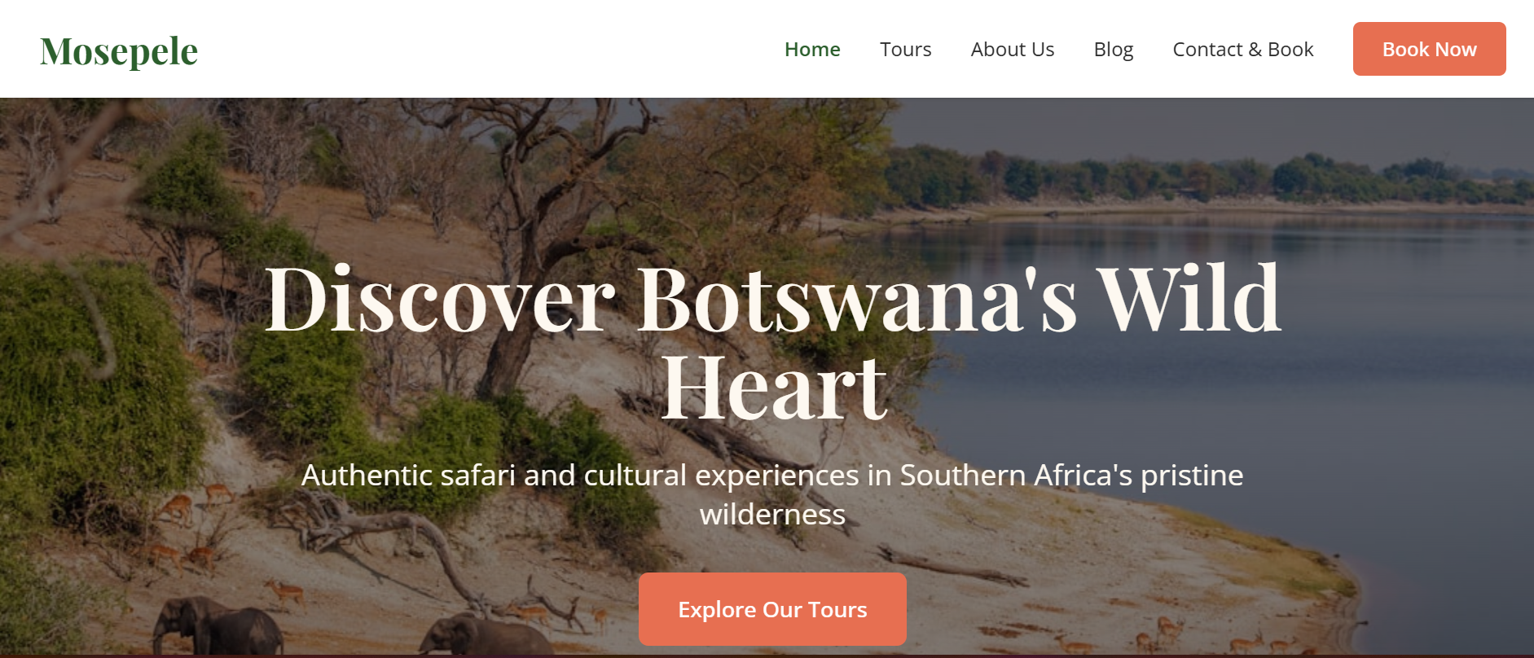
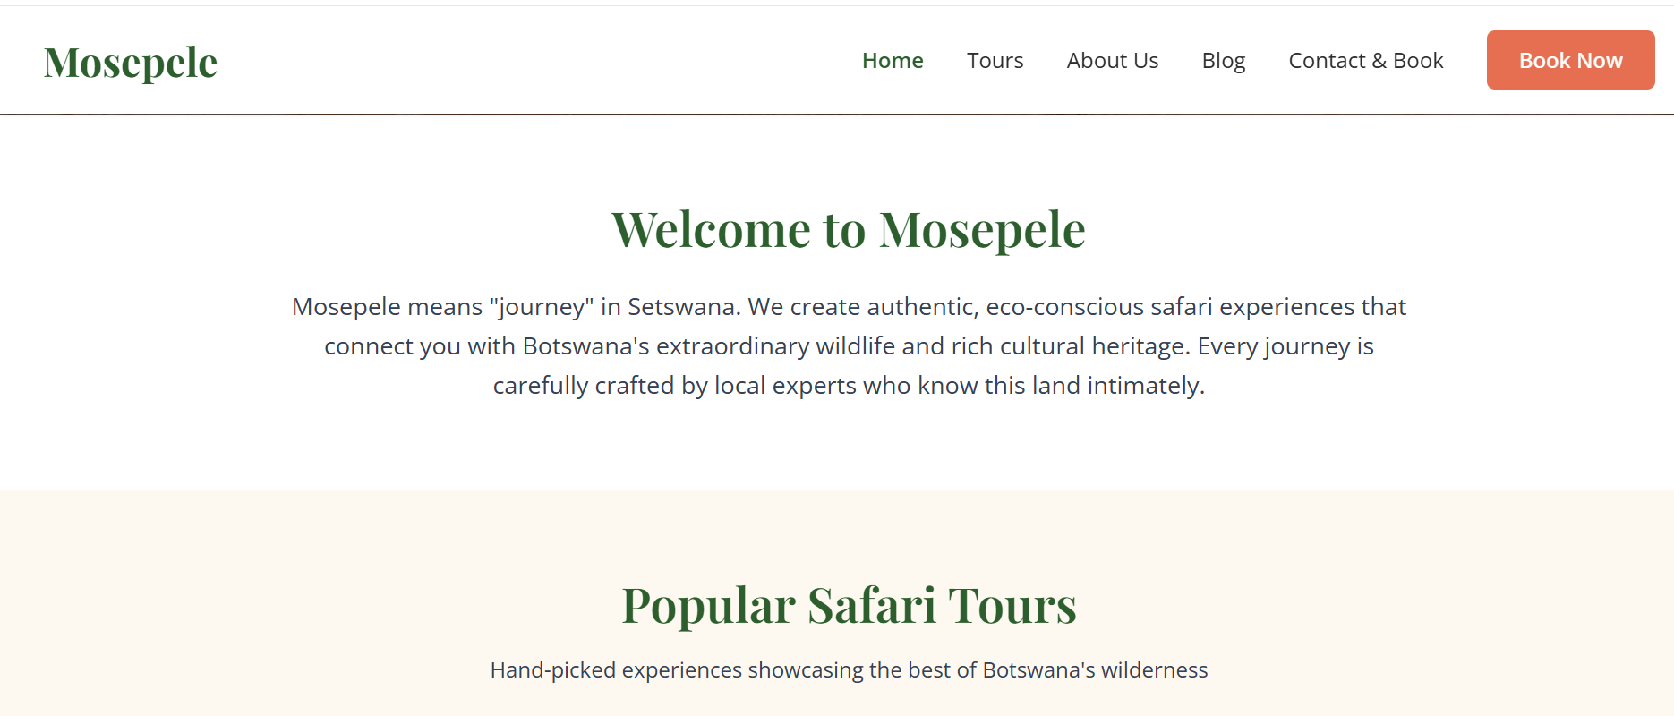

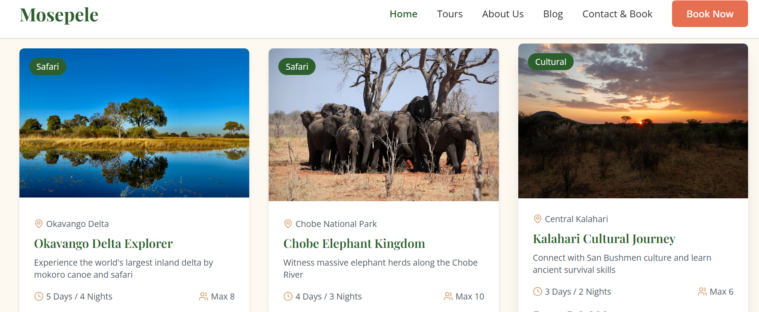
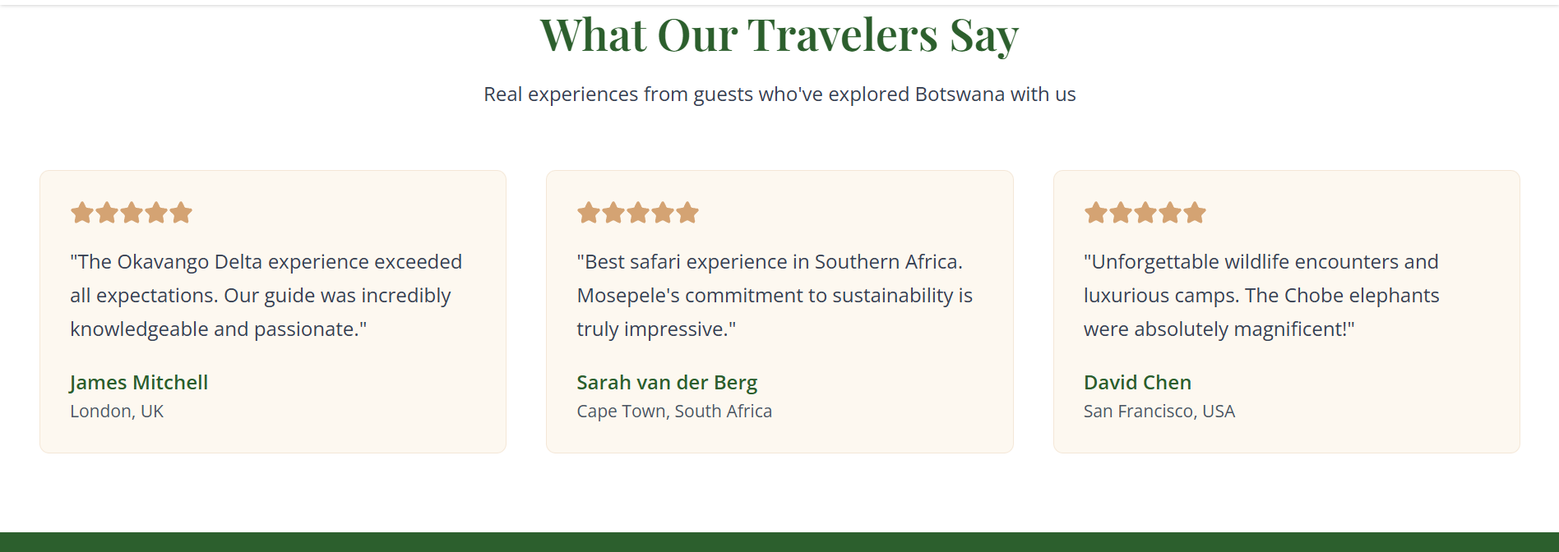
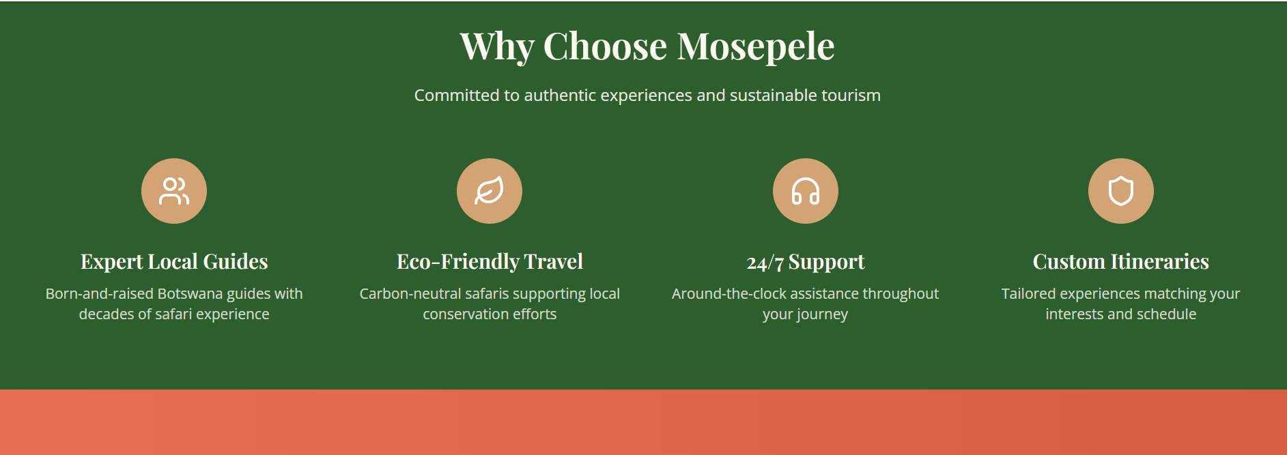

5.2 Contact & Book Wireframe (Desktop)
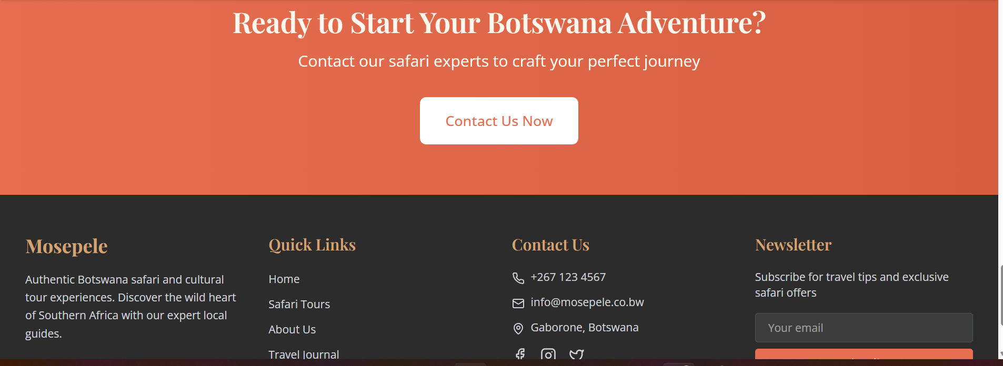

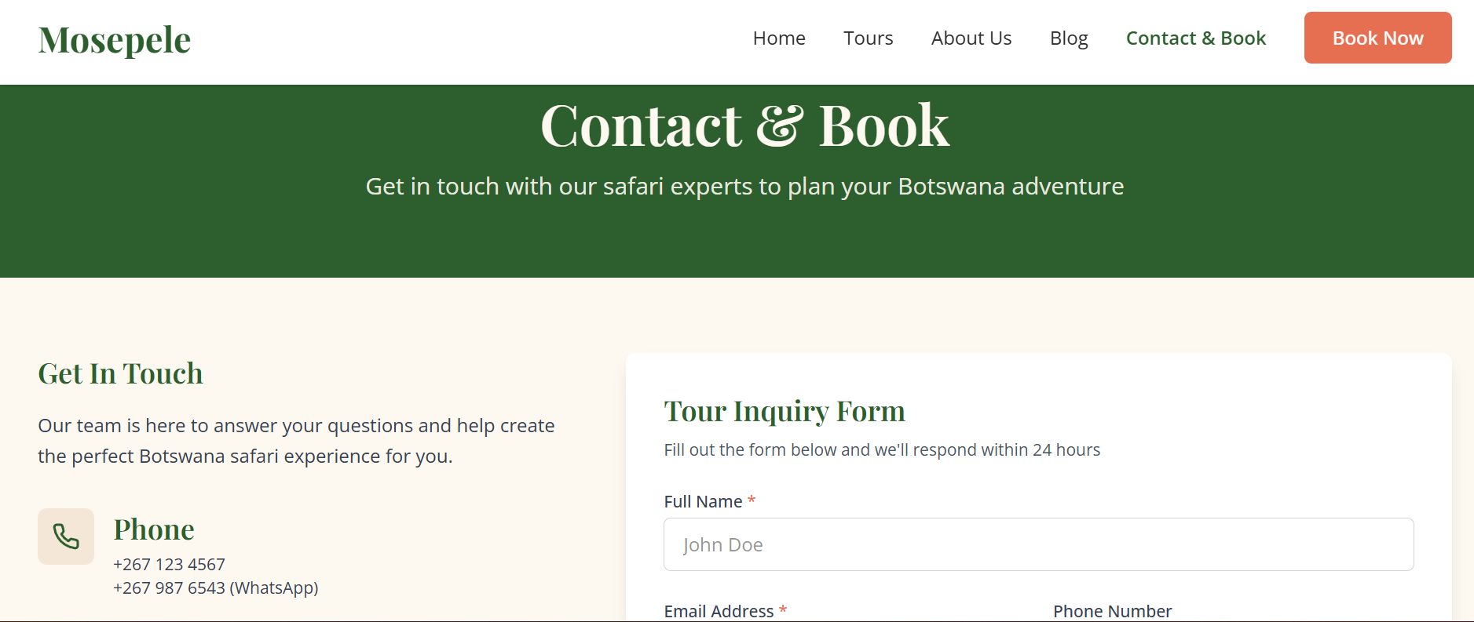
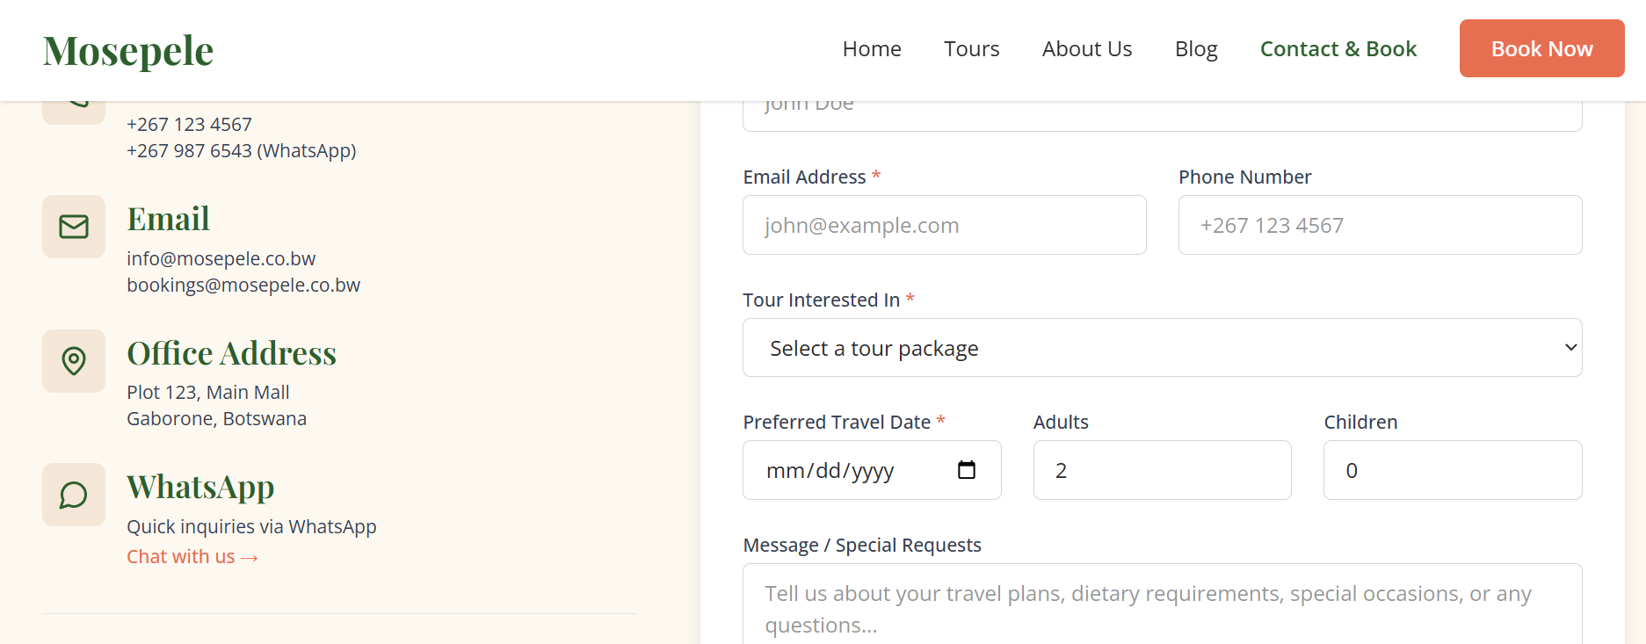
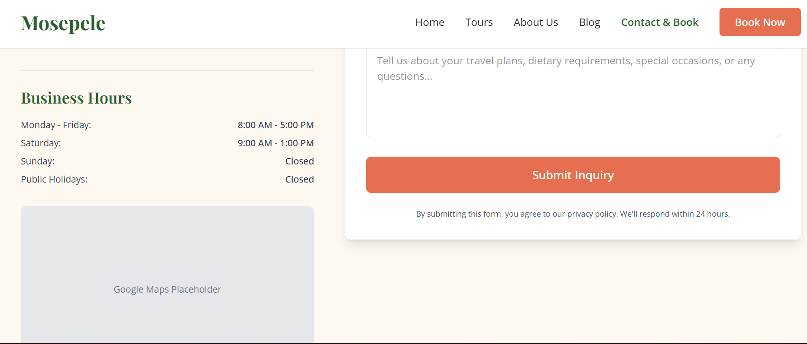

6. Design Assets & Styling Notes

Element | Specification
Primary Colour | Earthy green / savanna gold (to be defined from Mosepele brand guidelines).
Secondary Colour | Warm neutral (cream or sand) for backgrounds.
Accent/CTA Colour | Terracotta or sunset orange (high contrast for buttons).
Body Font | Sans-serif (e.g., Open Sans, Lato) for readability.
Heading Font | Serif or display font (e.g., Playfair Display) for elegance.
Button Style | Rounded corners, solid fill for primary, outline for secondary. Hover effect: darken 10%.
Card Style | Light shadow, border-radius 8px, white background.
Spacing | Consistent 2rem margins between major sections.

